This doc explains how the SAPE: Sub-band Aware Power-Equalization is designed based on srsRAN 4G

- Sub-band CQI feedback implementation
- This is where the Sub-band CQI is calculated based on our modifications.
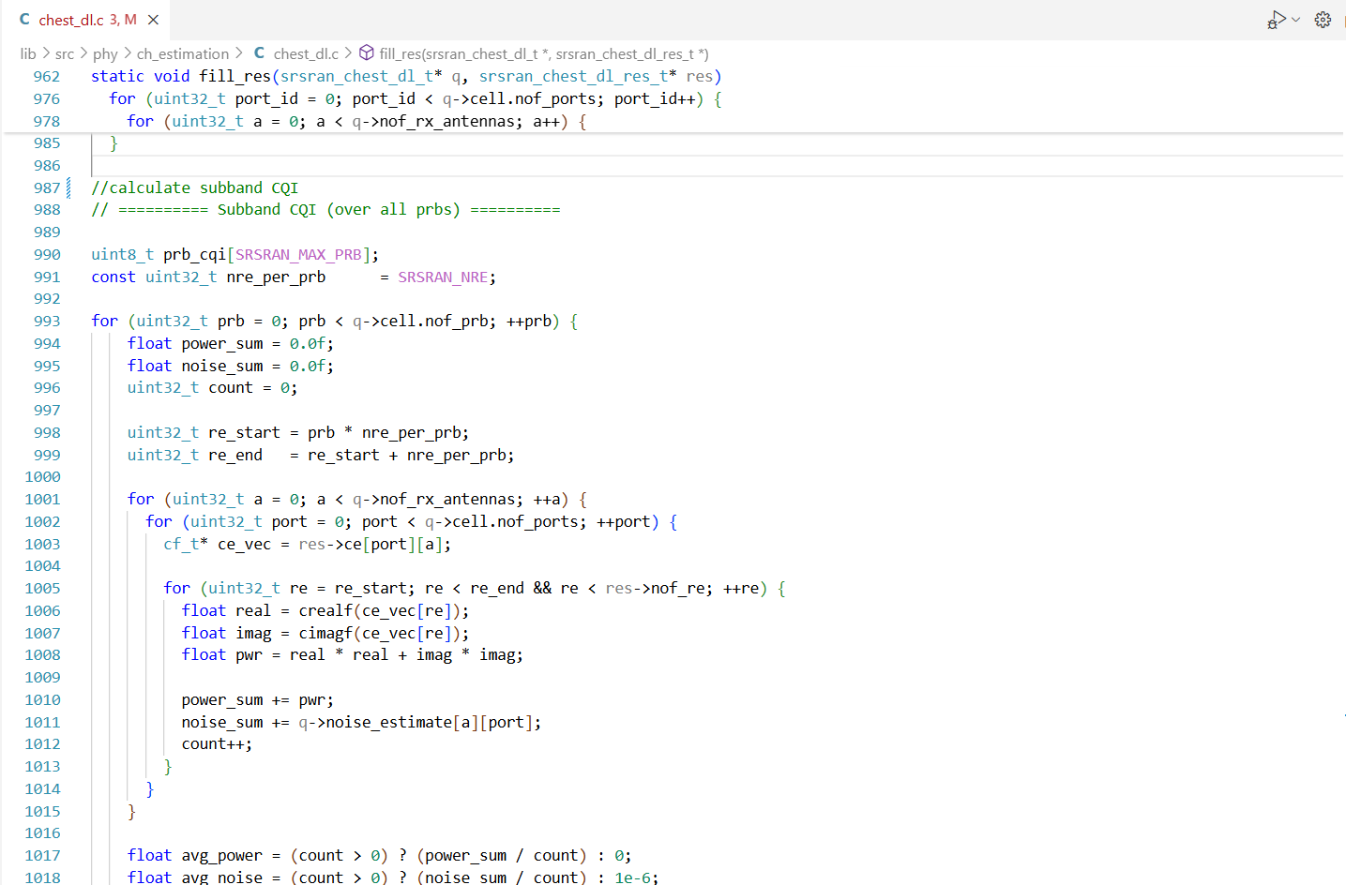

- This diagram explains how the Sub-band CQI feedback is transmitted and what functions in codebase are included.
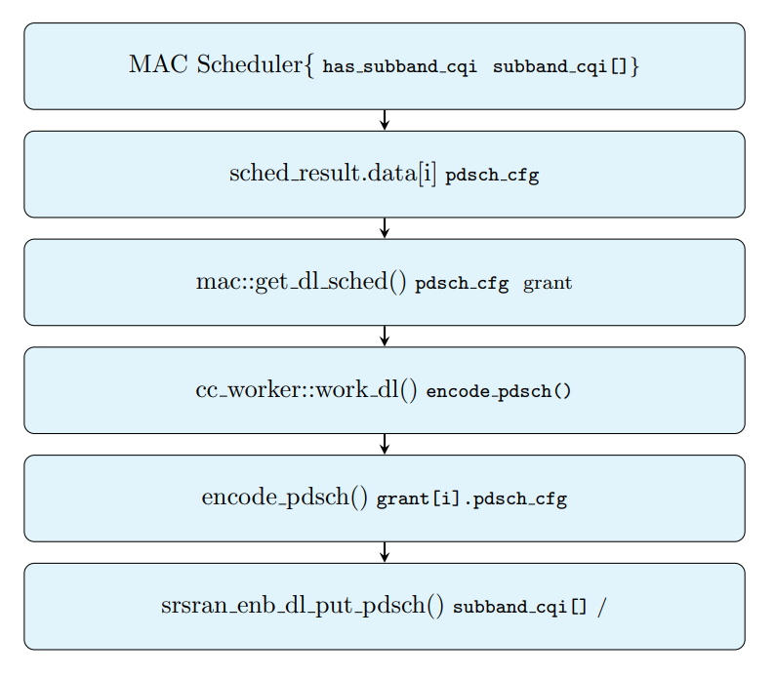

- Power-Equalization implementation
- Below is where the algorithm was implemented including the code section and the file name where the algorithm was put.
